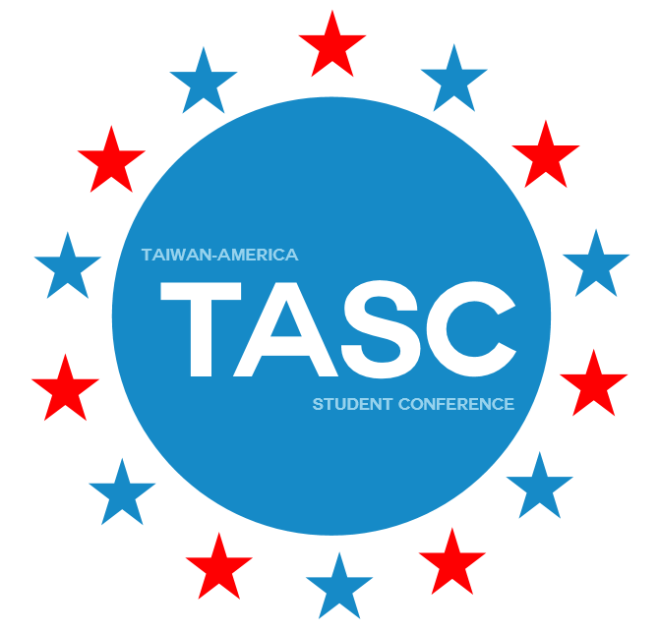
Taiwan-America Student Conference
Cancellation and Refund Policy

Delegates who decide to cancel after the confirmation deposit must provide an official notification listing the reasons for cancellation in an email sent to:

tasc01.pliao@gmail.com

The Delegate is responsible for the notification. The Delegate and/or any institution paying on the behalf of the Delegate are responsible for the all the program fees until the official notification is received by TASC directly from the Delegate. It is the Delegate’s responsibility to notify any institution paying the fee on his/her behalf for the cancellation.

TASC guarantees space in the program for the participant upon the payment of the non- refundable Confirmation Deposit. Cancellation after the Confirmation Deposit is effective from the date the official notification is received by TASC. The Delegate will continue to accumulate non-recoverable costs based on the chart below until official notification is received:

Cancellation Period | Penalty
45 days or more before the start of program | Deposit
30-45 days before the start of program | 40% of program fee (including deposit)
21-30 days before the start of program | 60% of program fee (including deposit)
7-21 days before the start of program | 75% of program fee (including deposit)
7 days or less before start of program | Full program fee (including deposit)

I understand the Cancelation and Refund Policy and accept its conditions.

Printed Name: ____________________________________________________________________
Signature: _______________________________________________________________________
*** Individuals under 18 years of age must have parent or guardian sign this form. ***
Printed Guardian’s Name: __________________________________________________________
Signature: _______________________________________________________________________

