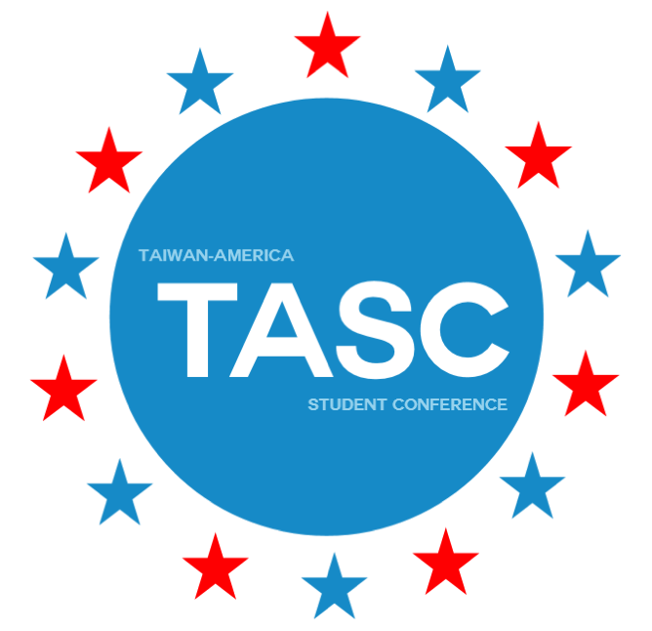
TASC Taiwanese Scholarship Application

- Full Name: ____________________

- E-mail Address: ________________________________________

- Sponsor: The Language Training and Testing Center (LTTC)

- Instruction:
There’s a limited number of LTTC-GEPT Scholarship for TASC that will be awarded to the most qualified applicants and/or those with the most demonstrated need. Those who need financial aid should specify their situation in their reply.
This Scholarship will cover NTD$10,000 of the NTD$20,000 conference fee. All scholarship applications will be carefully and independently reviewed, evaluated, and voted upon by LTTC committee.
Applicants must submit their applications alongside with their application form to jlee@taiwan-america.org. The deadline corresponds with the application deadline Feb. 29th. They will be notified of the final result by mid-June.
- Notice:
- Each scholarship winner must submit a piece of 800-word essay of reflection in Chinese after TASC for LTTC’s reference.
- The Scholarship won’t be given until LTTC reviews your essay upon your submission.
- To Apply:
Attach the following documents with your application form in one email and send to jlee@taiwan-america.org.
- This application with complete written information
- Personal Information Agreement (臺美學生會議個人資料提供同意書)
- The transcript of all the past semesters at your current school
- The verification of class ranking of all the past semesters at your current school
- Your GEPT High-Intermediate level certificate

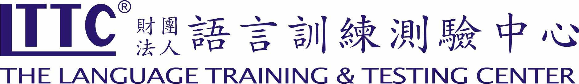

Scholarship Question
Please answer this question below in about 300 words in English.
- What are your post-graduate and/or career plans, and how do you see yourself contributing to U.S.-Taiwan relations after TASC?

